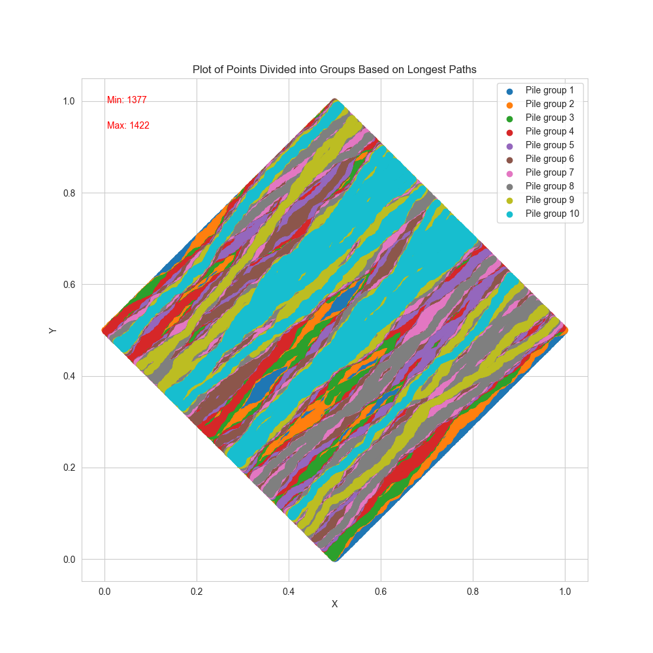Random 1M Points in 10 Rhombuses,  
Divided by The Longest Path Passing Through Them



